//Parameterized Constructor

public class StudentDetails {
int rollnum;
String name;

StudentDetails(int r,String n) { //Creating parameterized constructor
rollnum = r;
name = n;
}

void show() {
System.out.println("Roll Num : " + rollnum);
System.out.println("Name : " + name);
System.out.println("--------------------------");
}

public static void main(String args[]) {
StudentDetails s1 = new StudentDetails(30,"Poojitha");
StudentDetails s2 = new StudentDetails(42,"Sriya");
StudentDetails s3 = new StudentDetails(28,"Aparna");

s1.show();
s2.show();
s3.show();
}
}

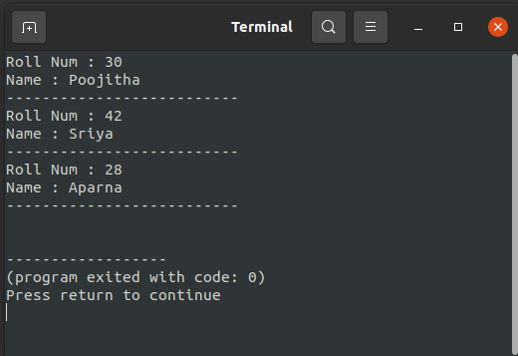
Output :

